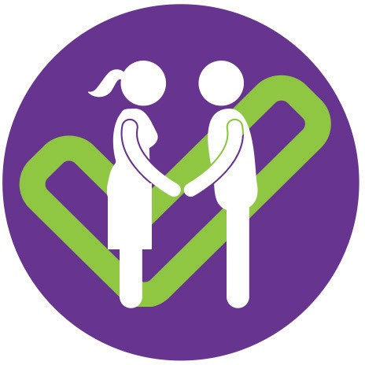

## Focusing on what works

**ParentsNext prepares you for employment by helping with:**

* **your skills** – basic skills like literacy, social skills, job-specific knowledge and job search know-how, for example by undertaking training or volunteering.
* **confidence and motivation** – helping you set goals and feel positive about your prospects, for example through mentoring
* **your stability and challenges** – sorting out issues that make it hard to work, by linking with things like housing, health or financial services.

Some people will find a job or start education or training while they are in ParentsNext; others will improve their readiness to do these things in the future.

## Welcoming parents of young children

YFS ParentsNext welcomes eligible parents from Logan. Some parents will be referred by Centrelink as a condition of receiving a Parenting Payment, which means they are required to attend appointments, undertake activities in their plan, and report on their participation.

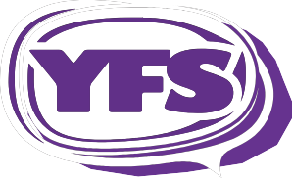

Building independence and participation

**Service Plan**

## Helping you prepare for a great future

YFS offers ParentsNext for Logan parents of young children. We help you prepare for future employment and gain confidence, skills and knowledge so you are ready to join the workforce when your children start school.

YFS has been helping the people of Logan to build independence and participation for more than 30 years. We can link you with schools, employment services, training providers, welfare agencies and community groups to help you to achieve your goals.

We also welcome parents of young children who are on a Parenting Payment and want help getting ready for work but aren’t referred by Centrelink. If you think you would benefit,

give us a call!

## Working with you all the way

At your first appointment, a YFS ParentsNext worker talks to you about your goals, strengths and any areas you might want help with.

Based on our discussions, we work with you to come up with a plan of action to help you prepare for work and overcome any challenges that make it hard for you to get a job.

Your YFS ParentsNext worker stays in touch to see how you’re going, offer advice and support and review your progress. As well as an appointment every three months, we keep in contact by phone, text or email depending on your preference.

The YFS ParentsNext team needs to hear from you. We’re asking parents like you for advice about how to make ParentsNext the best it can be. Our Parent Advisory Group helps us plan and improve our services. We welcome feedback through our website or in person.

Mon-Fri 8.30am - 5.00pm | Feedback Line: 07 3826 1596

For further information:

Phone: **1800 805 260** - Department of Employment National Customer Service Line (free call from land lines) Email: [nationalcustomerserviceline@employment.gov.au](mailto:nationalcustomerserviceline@employment.gov.au) Web: h[ttps://w](http://www.employment.gov.au/parentsnext)ww[.emplo](http://www.employment.gov.au/parentsnext)yment[.gov.au/parentsnext](http://www.employment.gov.au/parentsnext)

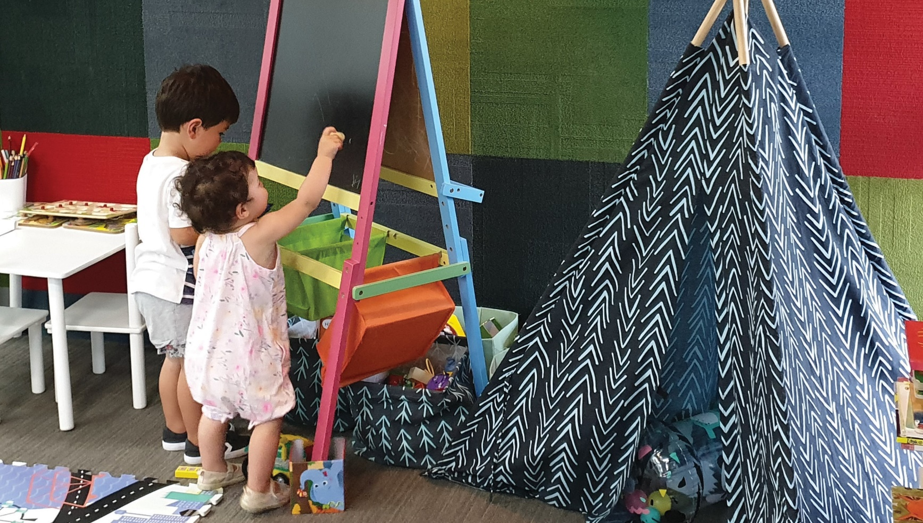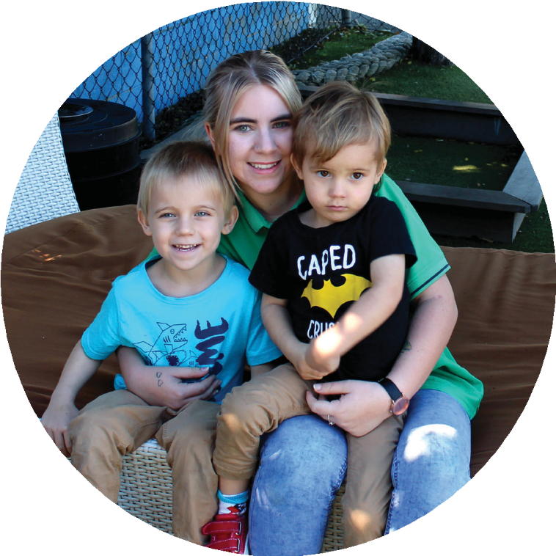

## Meeting your needs, respecting your rights

YFS offers our ParentsNext service at places that are accessible, centrally located, close to public transport and child-friendly. YFS offices have children’s playrooms and computer facilities you can use.

The YFS ParentsNext service is designed for everyone. If you have specific needs, for example if you need an interpreter, have a disability or have cultural considerations just let us know. YFS has extensive experience working with Aboriginal and Torres Strait Islander people; and we welcome people from all cultures and backgrounds.

We always treat you with respect, and do not share your information with others without your permission.

**Getting your perspective**

## Locations

YFS offers ParentsNext by appointment at:

**YFS, 376 Kingston Road, Slacks Creek YFS, 7/133 Brisbane Street, Jimboomba**

|

and at neighbourhood centres across Logan City as needed, including sites at Browns Plains, Yarrabilba, Flagstone, Springwood and Waterford West.

Phone: **07 3826 1500** Fax: 07 3808 9416 Email: [ParentsNext@yfs.org.au](mailto:ParentsNext@yfs.org.au) | Web: [www.yfs.org.au](http://www.yfs.org.au/)

|

|

yfslogan YFS Ltd l ABN 58 239 250 649 l ACN 167 122 527 l AS/NZS ISO 9001 AS/NZS ISO 14001

PP-YFS-ParentsNext-SDP-v3-0622-102270

Building independence and participation